1. Kernel parameter

Specifies the kernel type to be used in the algorithm.

Possible values: ‘linear’, ‘poly’, ‘rbf’, ‘sigmoid’, ‘precomputed’

Default value: ‘rbf’

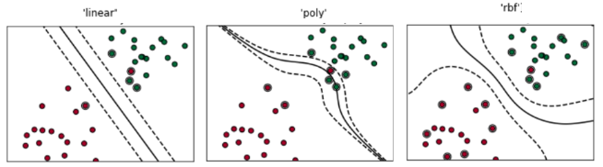

|  |  |  |  |  |  |  |  |  |  |
| --- | --- | --- | --- | --- | --- | --- | --- | --- | --- |
|  | linear | | | poly | | | rbf | | |
| 0 | 1 | 0.79 | 0.84 | 0.88 | 0.8 | 0.94 | 0.71 | 0.78 | 0.77 |
| 1 | 0.8 | 0.74 | 0.9 | 0.96 | 0.8 | 0.82 | 0.62 | 0.82 | 0.74 |

1. C

‘Degree of tolerance’

Float. Default value=1.0

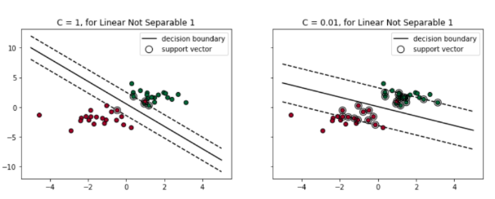

|  |  |  |  |  |
| --- | --- | --- | --- | --- |
| C |  | Precision | | |
| 0.01 | 0 | 0,79 | 0.8 | 0.83 |
| 1 | 0.77 | 0.71 | 0.82 |
| 1 | 0 | 0.92 | 0.9 | 0.81 |
| 1 | 0.82 | 0.82 | 0.71 |
| 3 | 0 | 0.8 | 0.79 | 0.78 |
| 1 | 0.68 | 0.35 | 0.62 |

1. Gamma parameter

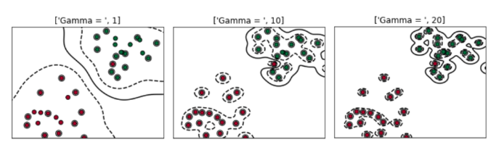

|  |  |  |  |  |
| --- | --- | --- | --- | --- |
| Gamma |  | Precision | | |
| 1 | 0 | 0.92 | 0.92 | 0.88 |
| 1 | 0.89 | 0.71 | 0.78 |
| 10 | 0 | 0.73 | 0.87 | 0.86 |
| 1 | 0.84 | 0.88 | 0.92 |
| 20 | 0 | 0.85 | 0.87 | 0.9 |
| 1 | 0.75 | 0.88 | 0.85 |

1. Degree parameter - only for ‘poly’ kernel- the differences are not that noticeable
2. Coef0 parameter same thing